Blazor project structure in the new unified model introduced in .NET 8 and continued in .NET 9 / .NET 10 Blazor Web App structure used for production applications.
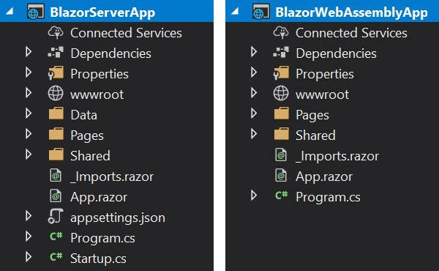

1. Default Project Structure (Unified Model)
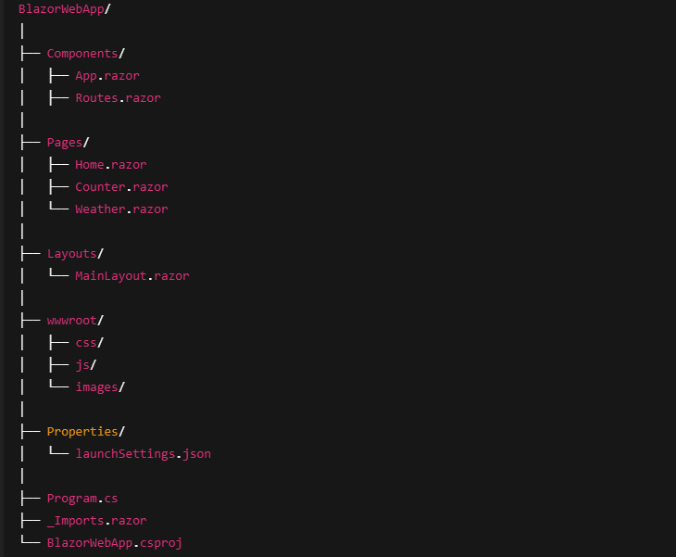

3. Core Folders Explained
Components/
- Contains core application components
- Includes app bootstrapping files
Typical files:
- App.razor – Root component
- Routes.razor – Central routing configuration
Purpose:
- App initialization
- Routing pipeline
- Render mode boundaries

Pages/
- Contains routable UI components
- Each page uses @page
Example:
@page "/products"
@rendermode InteractiveAuto
Purpose:
- Represents screens/pages
- Entry points for navigation

Layouts/
- Defines shared UI layout
- Controls structure across pages
- Uses @Body placeholder

Wwwroot/
- Contains static assets
  - CSS files
  - JavaScript files
  - Images
- Equivalent to wwwroot in ASP.NET Core MVC.
- In WebAssembly, everything here is downloaded to the browser.

4. Key Root Files
Program.cs
Central startup configuration:
- Service registration
- Render mode configuration
- Middleware pipeline
- Configures:
  - Services (DI)
  - Authentication / Authorization
  - HttpClient
  - Blazor hosting model
- Example responsibilities:
- builder.Services.AddRazorComponents()
- AddServerSideBlazor() or AddWebAssembly()

App.razor
Root component responsible for:
- Application routing
- Layout assignment
Now often delegates routing to Routes.razor.

Routes.razor (New in .NET 8+)
- Centralizes routing logic
- Separates routing from app initialization
Purpose:
- Cleaner architecture
- Easier route management

_Imports.razor
Global Razor imports:
- Common namespaces
- Shared components

.csproj
Defines:
- Target framework (net8.0, net9.0, net10.0)
- Blazor features
- Package references

5. Render Modes (Key Concept in .NET 8/10)
Blazor Web App supports per-component render modes:
Render Mode | Behavior
InteractiveServer | Server + SignalR
InteractiveWebAssembly | Runs in browser
InteractiveAuto | Server first, WASM later
Example:
@rendermode InteractiveWebAssembly
This is the biggest architectural change in modern Blazor.

6. Recommended Enterprise Additions
├── Services/ → Business logic & API calls
├── Models/ → DTOs / ViewModels
├── State/ → App state containers
├── Auth/ → Authentication / Authorization
├── Infrastructure/ → External integrations

7. Execution Flow (Simplified)
- App starts in Program.cs
- Root component (App.razor) loads
- Routing handled by Routes.razor
- Layout applied
- Page rendered with chosen render mode
- Components become interactive

